

**TEAM 1_ONLINE SHOP**

**Software Requirement Specification**

– Hanoi, May 2022 –

**Table of Contents**

I. Overview

1. Introduction

2. Common Requirements

II. Functional Requirements

1. Marketing
2. Common
3. Admin
4. Customer
5. Sale

**I. Overview**

**1. Introduction**

The web application of the Online Procurement System (ShopOnline) for furniture stores aims to provide complete solutions to suppliers as well as customers through the single use of the internet. It allows customers to choose their favorite items as well as featured items and great promotions (Slider). See the positive as well as negative feedback of other customers (Feedback). Together share beauty secrets, know how to buy at the right time (Blogs).

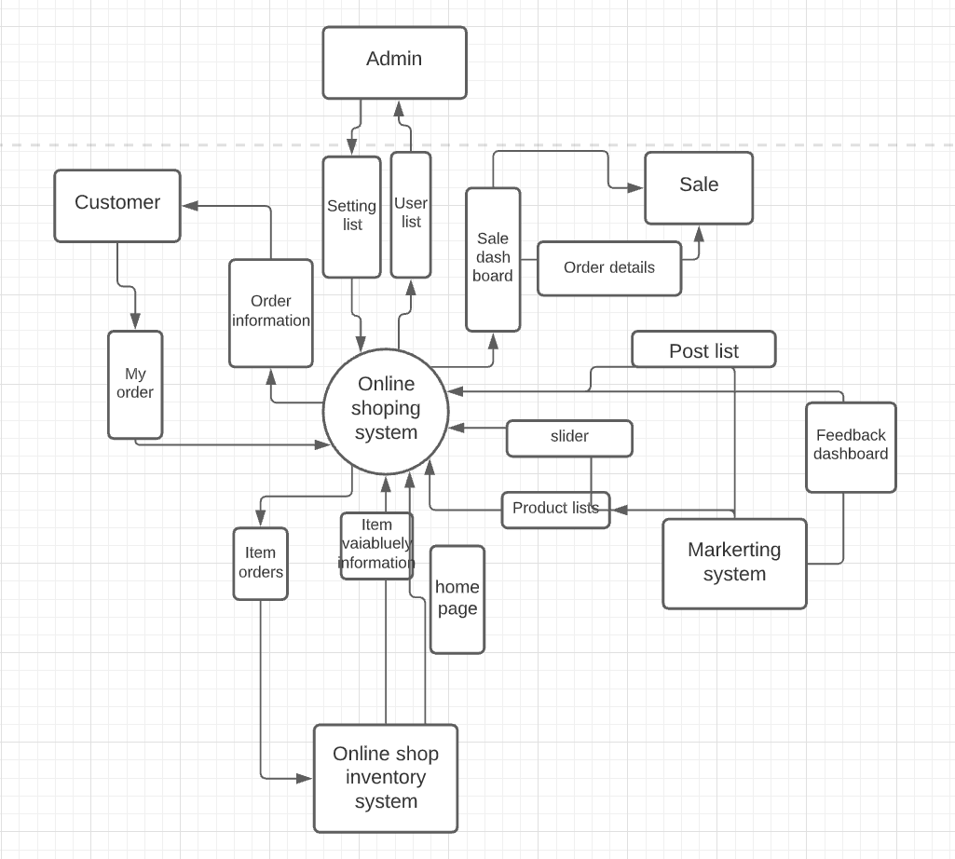

**2. System Functions**

*a. Screen Flow*

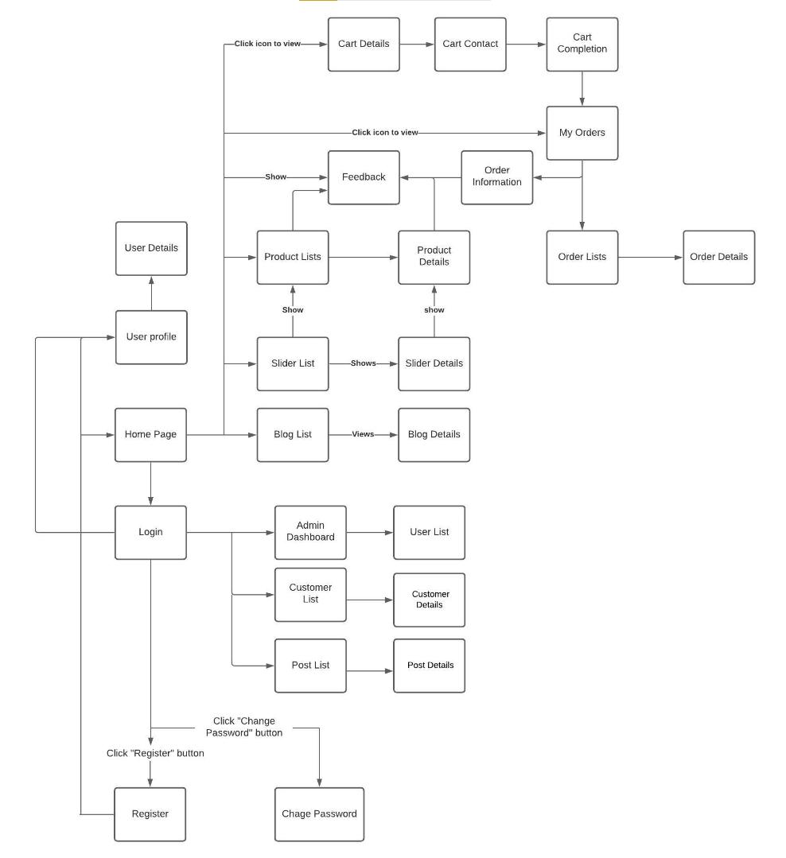

*b. User Authorization*

|  |  |  |  |
| --- | --- | --- | --- |
| **Screen/Functions** | **Admin** | **Customer** | **User** |
| Homepage | X | X | X |
| Blog | X | X | X |
| Blog Detail | X | X | X |
| Feedback |  |  | x |
| Feedback List | X | X |  |
| Feedback Detail |  | x |  |
| User Login | X | X | X |
| User Register |  | X | X |
| Slider list | X | X | X |
| Products List | X | X | X |
| Product Details | X | X | X |
| User Profile | X | X | X |
| Users List | X |  |  |
| User Details | X |  |  |
| Change Password | X | X | X |
| Customers List | X |  |  |
| Customer Details | X |  |  |
| Orders List | X |  |  |
| Posts List | X | X |  |
| Post Details | X | X |  |
| Order Information | X |  |  |
| Order Details | X |  |  |
| My Orders | X |  | X |
| Cart Contact | X |  | X |
| Cart Details | X |  | X |

**II. Functional Requirements**

**1. Marketing**

**2. Common**

**3. Admin**

**4. Customer**